Commonwealth Room Booking System
User Guidance Notes

April 2026 | For all platform users

1. Introduction
The Commonwealth Room Booking System is the official platform for reserving meeting rooms across Commonwealth offices. It enables staff and external delegates to search for rooms, check availability, submit booking requests, and manage their reservations — all from a single web application.
This guide covers all standard (non-administrative) features of the system. It is intended for:
- Commonwealth Secretariat and High Commission staff using the platform to book rooms.
- External delegates and guests invited to use the system for event bookings.
Note: Administrative functions — room management, booking approvals, user management — are covered in a separate administrator guide.

2. Getting Access
There are two ways to access the platform depending on whether you are a Commonwealth staff member or an external user.

2.1 Logging In
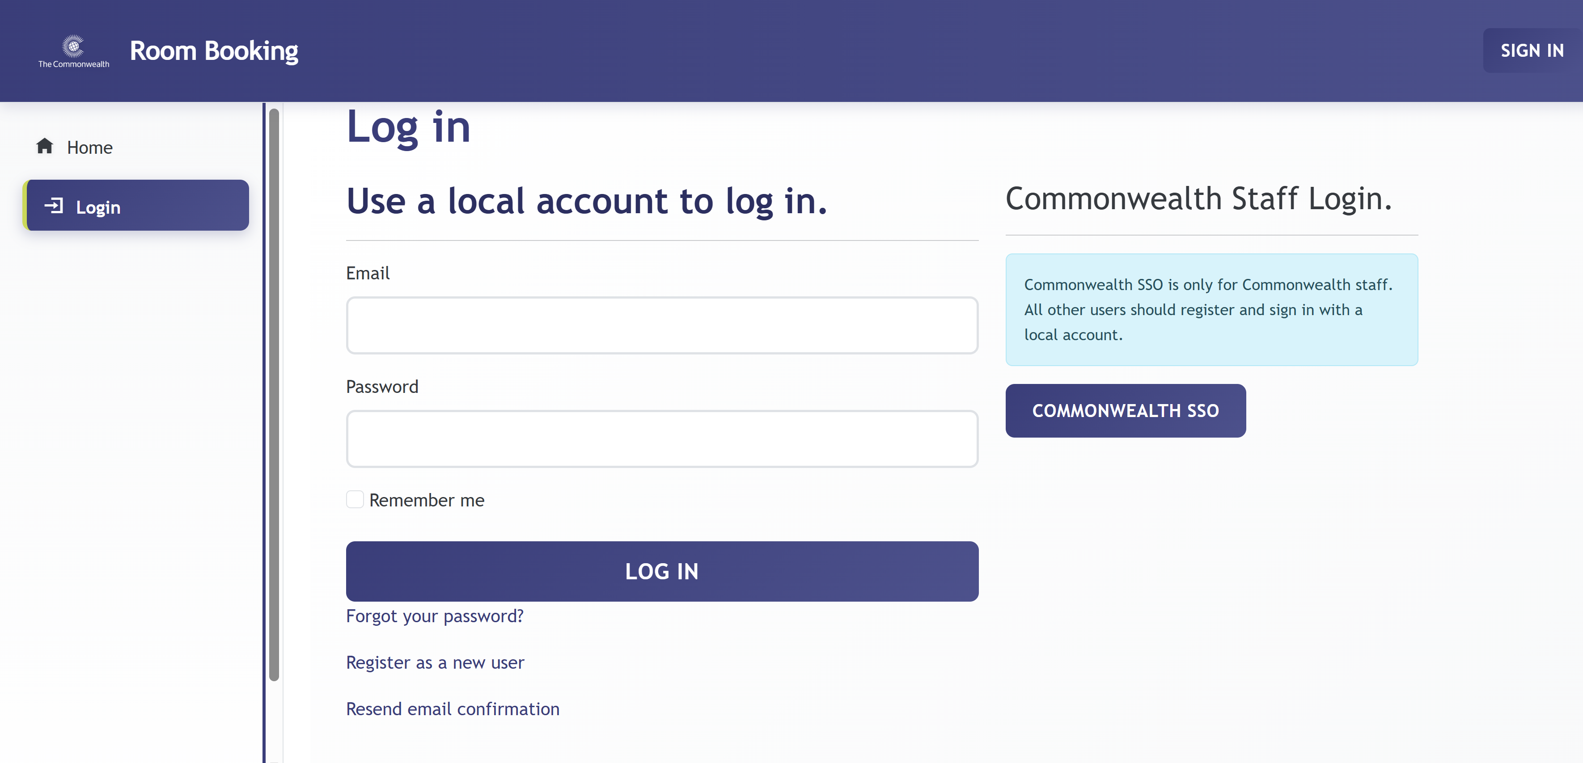Navigate to the platform and click Login in the sidebar. The login page offers two methods:
- Local account login (left side) — for external users or anyone who registered with an email and password. Enter your Email and Password, then click LOG IN.
- Commonwealth Staff Login (right side) — for all Commonwealth Secretariat. Click COMMONWEALTH SSO. You will be redirected to the Commonwealth Microsoft 365 sign-in page; log in with your @commonwealth.int credentials.
Note: Commonwealth SSO is for Commonwealth staff only. All other users must use the local account form. If you are unsure, check with the administrator who invited you.
Additional links on the login page: https://roombooking.commonwealth.int/Account/login
- Forgot your password? — sends a password-reset link to your registered email.
- Register as a new user — opens the registration form for external users.
- Resend email confirmation — re-sends the account verification email if you did not receive it.

2.2 Registering as a New User
External users (guests, delegates, and non-Commonwealth staff) must register for an account. Commonwealth staff do not need to create a new account — they use Commonwealth SSO directly.
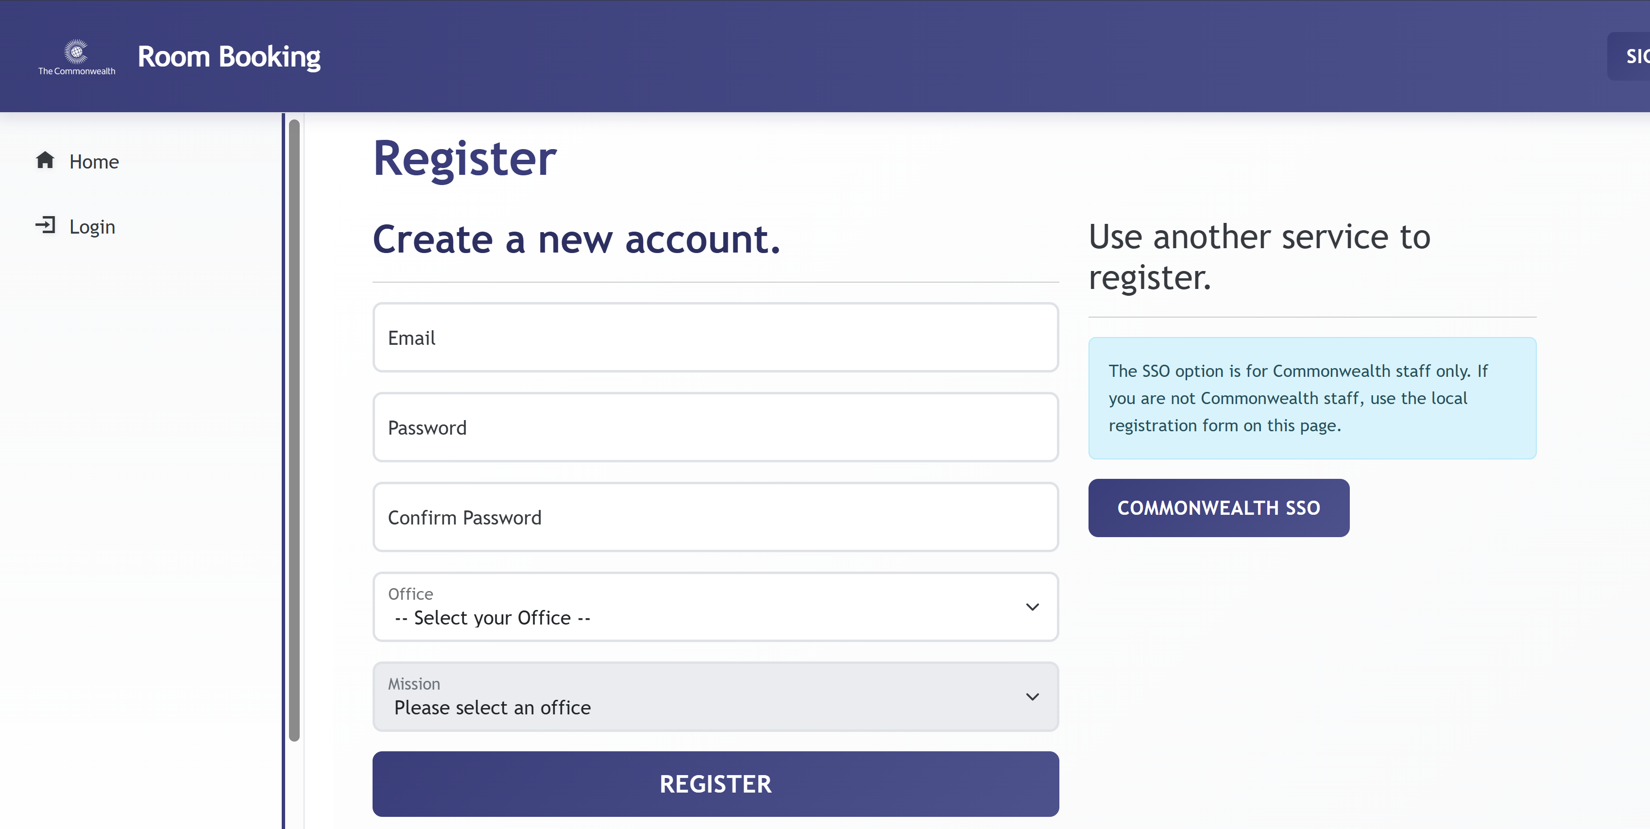
To register:
- Click Register as a new user on the login page.
- Complete the form on the left side:
- Email — your work email address. This becomes your username.
- Password / Confirm Password — choose a secure password.
- Office — select the office you are associated with or will be visiting.
- Mission — select your mission or delegation (updates once Office is chosen).
- Click REGISTER to submit.
- Check your email for a confirmation link and click it to activate your account.
Note: The SSO option on the right is for Commonwealth staff only. If you are not Commonwealth staff, use the form on the left.

3. The Home Page
After logging in you are taken to the Home page — the main dashboard. From here you can browse rooms, search for availability, and reach all key features.
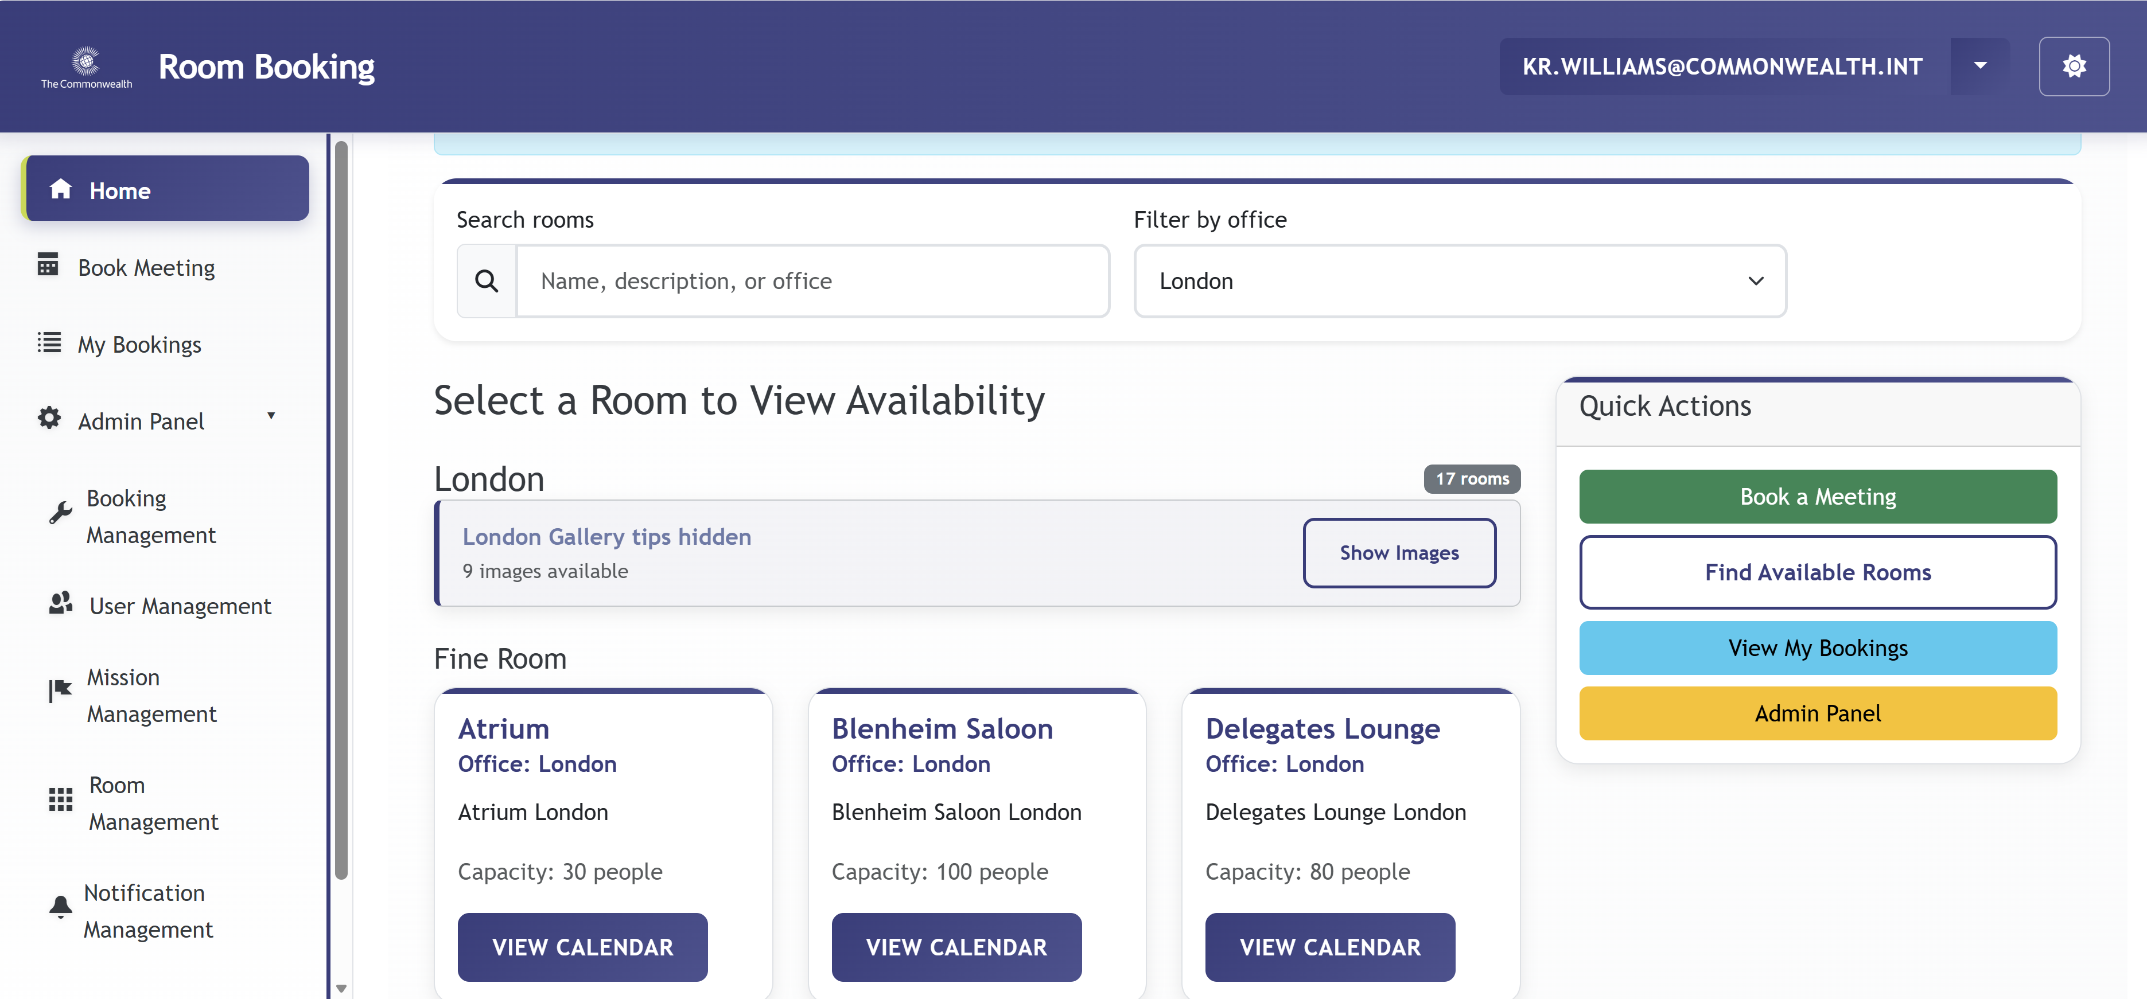

3.1 Navigation Sidebar
The left-hand sidebar is the primary navigation:
- Home — returns to the main room-browsing dashboard.
- Book Meeting — opens the booking request form.
- My Bookings — shows all your submitted booking requests.
- Admin Panel — visible to administrators and office managers only (not covered in this guide).
The top bar shows your logged-in email. Click the gear icon (⚙) on the right to access account settings.

3.2 Tips Panels
Each page includes collapsible tips panels with page-specific guidance. Tips are hidden by default.
- Click Show tips to read the guidance.
- Click Hide tips to collapse it again.
The Home page includes two panels: Choosing the right room and an office-specific resources panel (e.g., London Office Resources).

3.3 Browsing Rooms
The main area lists all rooms visible to you, grouped by office and then by room category (e.g., Fine Room, Conference Room). Each room card shows:
- Room name
- Office
- Short description
- Capacity (number of people) or number of available layouts
- VIEW CALENDAR button
Note: Some offices include a Photo Gallery panel. Click Show Images to browse photos of the rooms before booking.

3.4 Searching and Filtering Rooms
- Search rooms — type a room name, description, or office name to filter the cards in real time.
- Filter by office — use the dropdown to show only rooms from a specific office.

3.5 Quick Actions
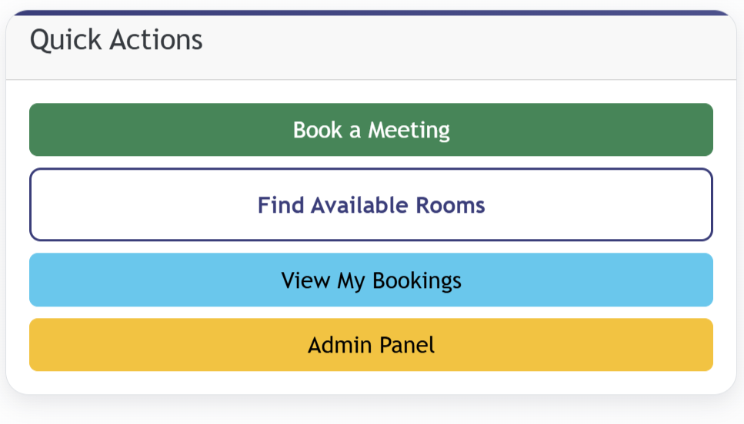
The Quick Actions panel (right side of the page) provides one-click shortcuts:
- Book a Meeting (green) — goes directly to the booking form.
- Find Available Rooms (outlined) — opens the room-search-by-requirements page.
- View My Bookings (blue) — opens your bookings list.
- Admin Panel (yellow) — administrators and office managers only.

4. Viewing Room Availability
Before booking, you can check when a specific room is free by viewing its calendar.

4.1 Room Calendar
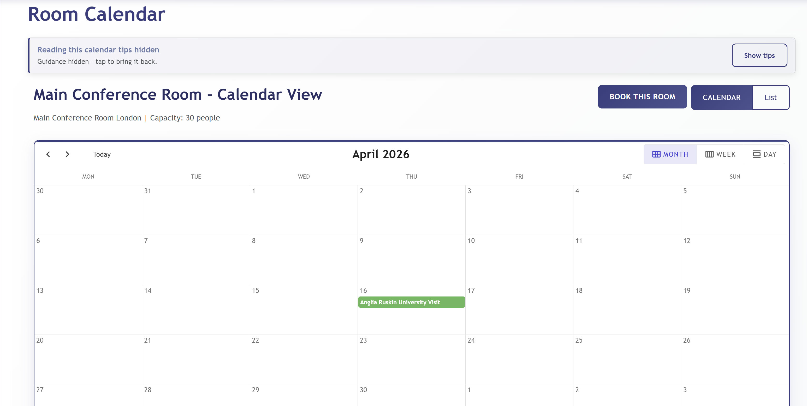
Click VIEW CALENDAR on any room card to open its availability calendar. The page shows:
- Room name and capacity.
- A full calendar with all approved bookings shown as coloured event blocks.
- View toggle: MONTH / WEEK / DAY — zoom into specific periods.
- Navigation arrows and a Today button.
Note: External users and users from other missions will see bookings as generic ‘Busy’ blocks without meeting details. Only the organiser, main contact, and administrators can see full meeting names.

4.2 Booking from the Calendar
Once you have identified a free slot:
- Click BOOK THIS ROOM (top right of the calendar page).
- The Book Meeting form opens with that room pre-selected.

4.3 List View
Click the List tab next to the CALENDAR button to switch to a tabular list of upcoming bookings for that room.

5. Finding Available Rooms
If you have specific requirements but are flexible on which room to use, the Find Available Rooms tool searches across all rooms and returns only those free for your chosen slot.
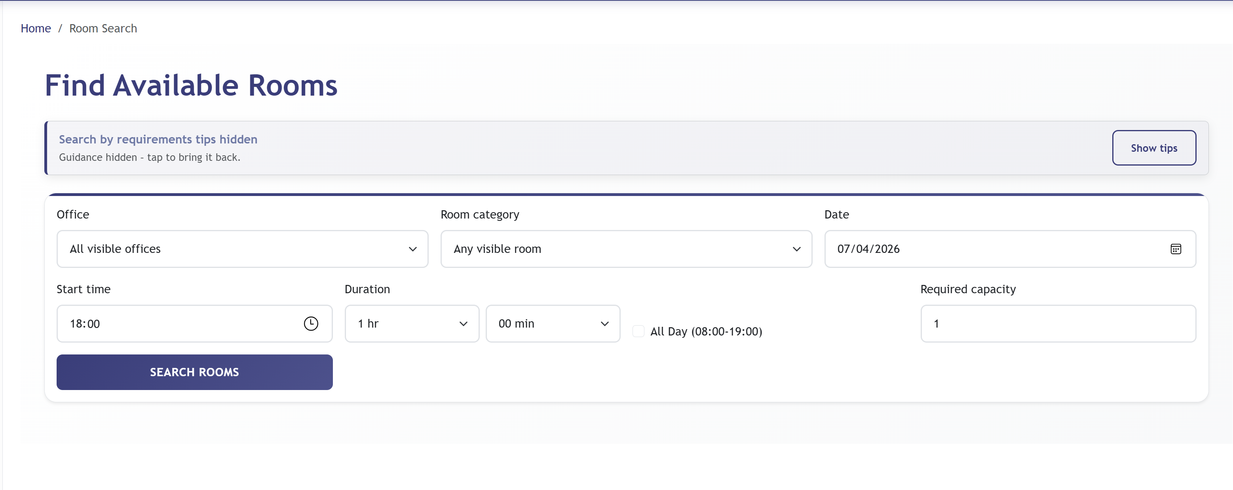
To search:
- Click Find Available Rooms from the Quick Actions panel or the navigation.
- Set your search criteria:
- Office — filter to a specific office, or leave as 'All visible offices'.
- Room category — filter by room type, or leave as 'Any visible room'.
- Date — select the date of your meeting.
- Start time — set the meeting start time.
- Duration — specify how long the meeting will run.
- All Day (08:00–19:00) — tick to search for rooms free the entire working day.
- Required capacity — minimum number of people the room must seat.
- Click SEARCH ROOMS. Results show all rooms free for that slot and meeting the capacity requirement.

6. Booking a Meeting Room
Access the booking form via the sidebar (Book Meeting), the Quick Actions panel, or the BOOK THIS ROOM button on a room’s calendar.

6.1 The Booking Form — Room & Participants
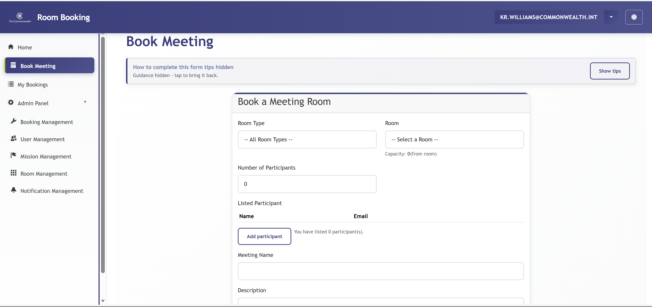

Room Selection
- Room Type — optionally filter rooms by category. Leave as 'All Room Types' to see every room.
- Room — select the desired room. The capacity or number of layouts is shown below the dropdown once a room is chosen.
Note: If a room shows '2 layouts' (or similar), the room has configurable seating arrangements (e.g., Theatre, Boardroom, U-Shape). Discuss the preferred layout with the office administrator at the time of approval.

Participants
- Number of Participants — total expected headcount.
- Listed Participants — click Add participant to add individual attendees by name and email. These are formally listed delegates. Add as many as required.

Meeting Details
- Meeting Name — a short title for the booking (e.g., 'Q2 Strategy Review').
- Description — a brief description of the meeting’s purpose.

6.2 The Booking Form — Requirements & Timing
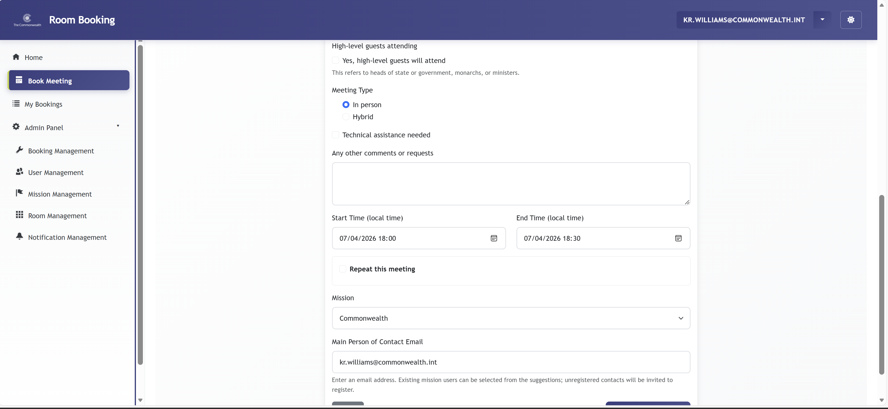
- High-level guests attending — tick if heads of state, government officials, monarchs, or ministers will be present.
- Meeting Type — select In person or Hybrid.
- Technical assistance needed — tick if you require AV or IT support.
- Any other comments or requests — free text for any additional requirements (catering, room setup, etc.).

Date & Time
- Start Time (local time) — date and time the meeting begins, entered in your local time zone.
- End Time (local time) — date and time the meeting ends.
Note: The system adjusts for time zone differences when generating calendar invites. Always enter times in your own local time zone.

Repeat This Meeting
Click Repeat this meeting to expand recurring options and schedule a series of bookings with a single request:
- Repeat type — Daily, Weekly, or Monthly.
- Repeat interval — e.g., every 1 week, every 2 weeks.
- End date — when the series stops.
Note: Each occurrence in a recurring series is created as an individual booking request and must go through the approval process separately.

Mission and Contact
- Mission — select your mission or delegation. Defaults to your registered mission.
- Main Person of Contact Email — email of the primary contact for this booking (can be you or a colleague). Existing system users appear as suggestions; non-registered contacts will receive an invitation to register.

6.3 Submitting Your Request
Click REQUEST BOOKING at the bottom of the form to submit. Click Cancel to discard and return to the Home page.
After submitting:
- You receive a confirmation email acknowledging the request.
- The booking status is set to Requested (pending review).
- Once a decision is made you receive a further email notification.
- If approved, a calendar invite (.ics file) is attached to the approval email.
Important: Submitting a request does not confirm the room. All bookings require approval. Do not treat the room as confirmed until you receive an approval notification.

7. My Bookings
The My Bookings page lists all booking requests you have submitted or on which you are listed as the Main Contact.

7.1 Viewing Your Bookings
[ Screenshot: My Bookings page — showing booking table with columns: Meeting, Room, Date & Time, Organizer, Mission, Participants, Status, Requirements, Actions ]
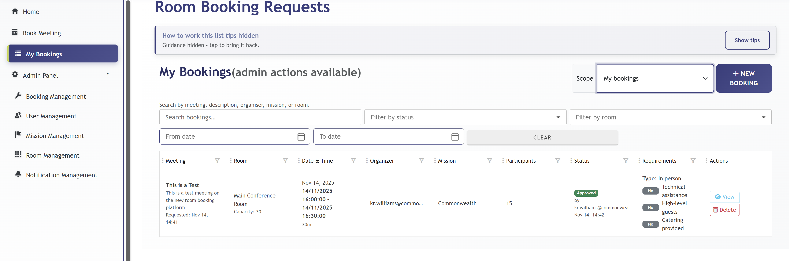
Each row shows: Meeting name and description, Room, Date/Time, Organizer, Mission, Participants, Status (colour-coded), Requirements flags, and View / Delete action buttons.

7.2 Booking Statuses
- Requested (blue/grey) — submitted and awaiting review.
- Approved (green) — confirmed; the room is reserved.
- Rejected (red) — not approved. Open the booking to see the reason.

7.3 Filtering and Searching
- Search bookings… — search by meeting name, description, organiser, mission, or room.
- Filter by status — show only Requested, Approved, or Rejected bookings.
- Filter by room — narrow to a specific room.
- From date / To date — limit results to a date range.
- CLEAR — resets all filters.

7.4 Scope Selector
The Scope dropdown (top right) controls which bookings are listed:
- My upcoming bookings — future bookings only (default).
- My bookings — all bookings including past ones.

7.5 New Booking & Deletion
- + NEW BOOKING — opens the Book Meeting form without returning to the Home page.
- Delete — cancels and permanently removes a booking. Only the creator can delete. Deleting an approved booking notifies the office administrator.
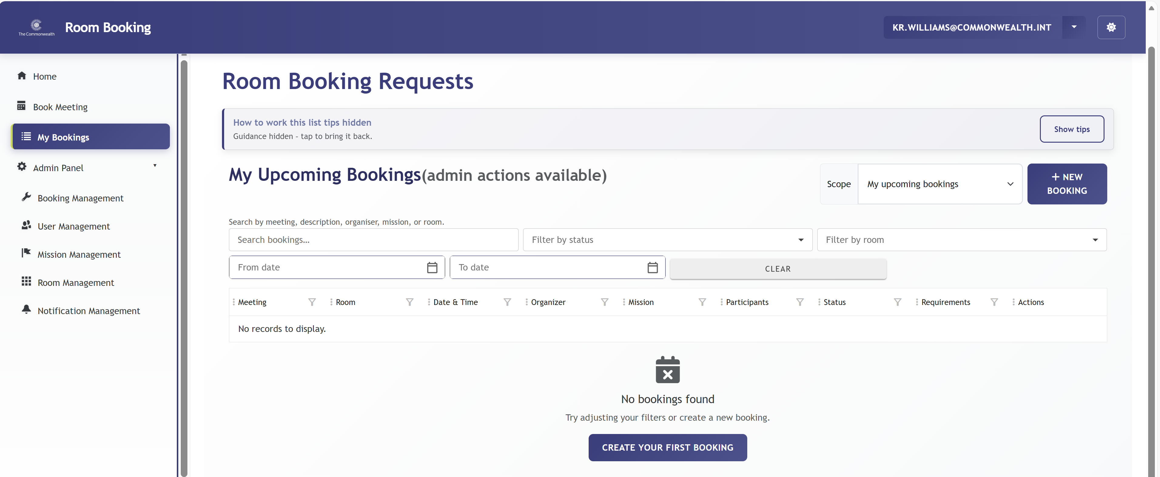
Important: Deletion is permanent and cannot be undone.

8. Booking Details
Click View on any row in My Bookings to open the full Booking Details page.
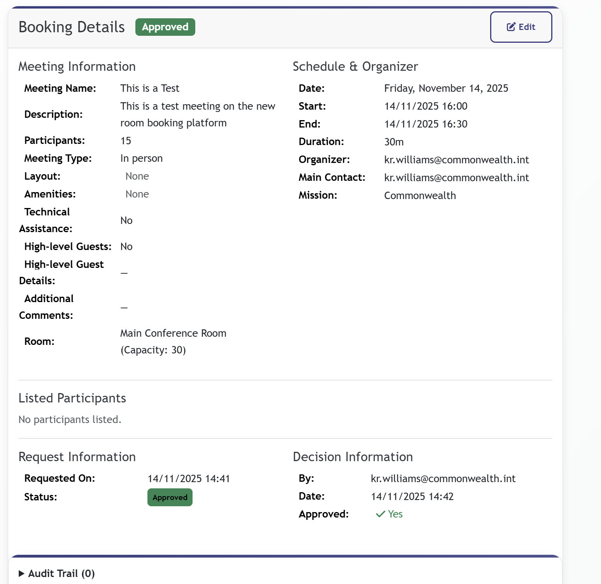

8.1 Sections at a Glance
- Meeting Information — all details entered at booking: name, description, participants, meeting type, room layout, amenities, technical assistance, high-level guests, additional comments, and room with capacity.
- Schedule & Organiser — date, start/end times, duration, organiser email, main contact, and mission.
- Listed Participants — individually named attendees added during booking.
- Request & Decision Information — submission date/time, current status, and (if decided) the approver name, decision date, and outcome.
- Audit Trail (expandable) — a full log of every action taken on the booking: submission, approval/rejection, edits, and document uploads.

8.2 Editing a Booking
If you are the organiser and the booking has not yet been decided, click the Edit button (top right) to update details. Re-submitting an edited booking resets its status to Requested.

8.3 Uploading Supporting Documents
While your booking is in Requested status, you (as the organiser or Main Contact) can attach supporting documents to assist the reviewer.
- Open the Booking Details page for your Requested booking.
- Scroll to the Supporting Documents section.
- Click Upload Documents and select the file(s) from your device.
- Files are immediately attached and visible to the approving administrator.
Note: Document upload is only available while the booking is in Requested status. Only the organiser or Main Contact can upload documents.

9. Managing Your Account
Click the gear icon (⚙) in the top-right corner of any page to open your account settings.

9.1 Profile
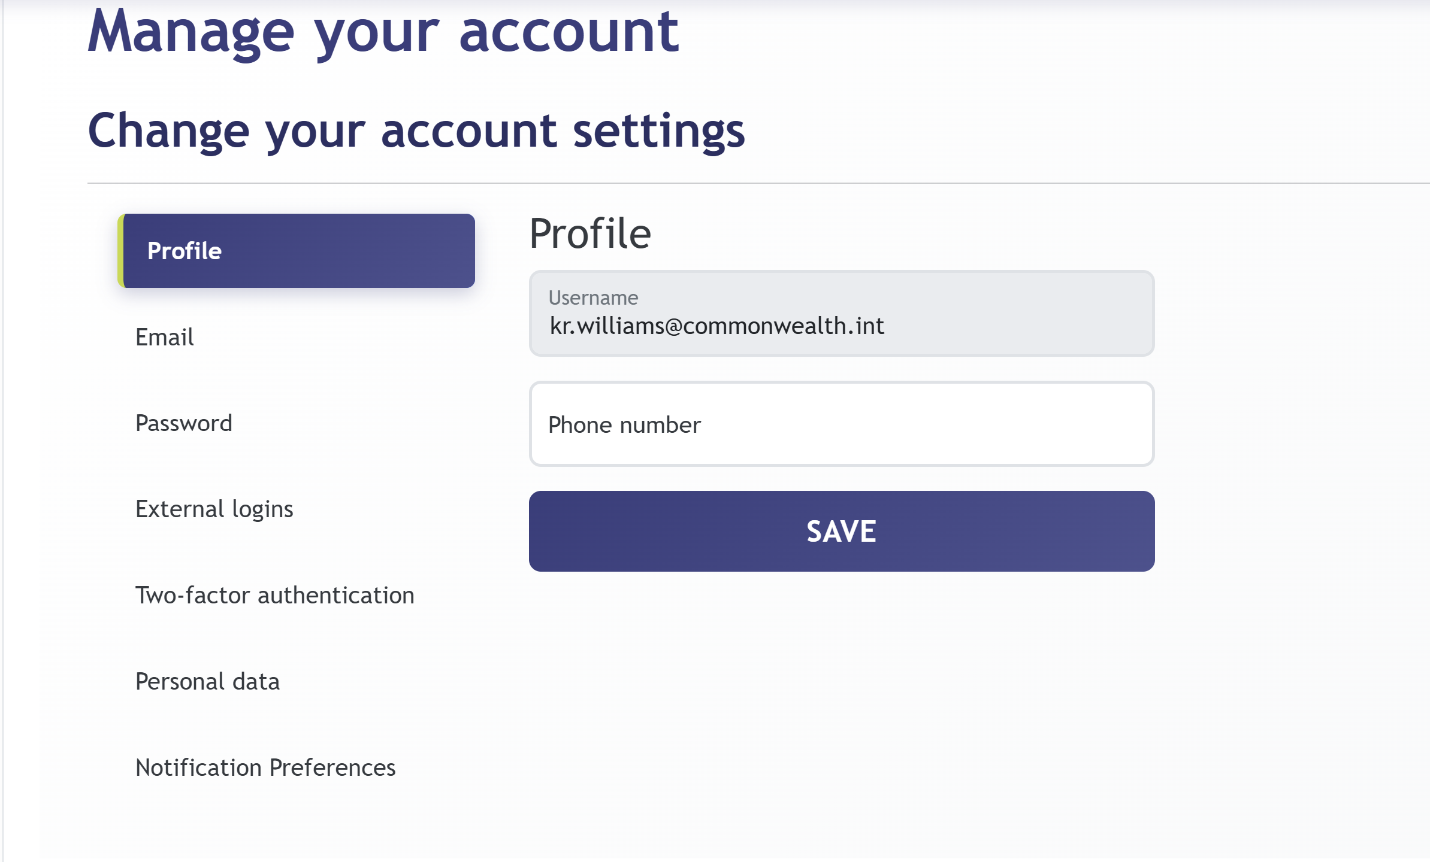
Shows your username (email address — read-only) and allows you to add or update a Phone number. Click SAVE to apply.

9.2 Email
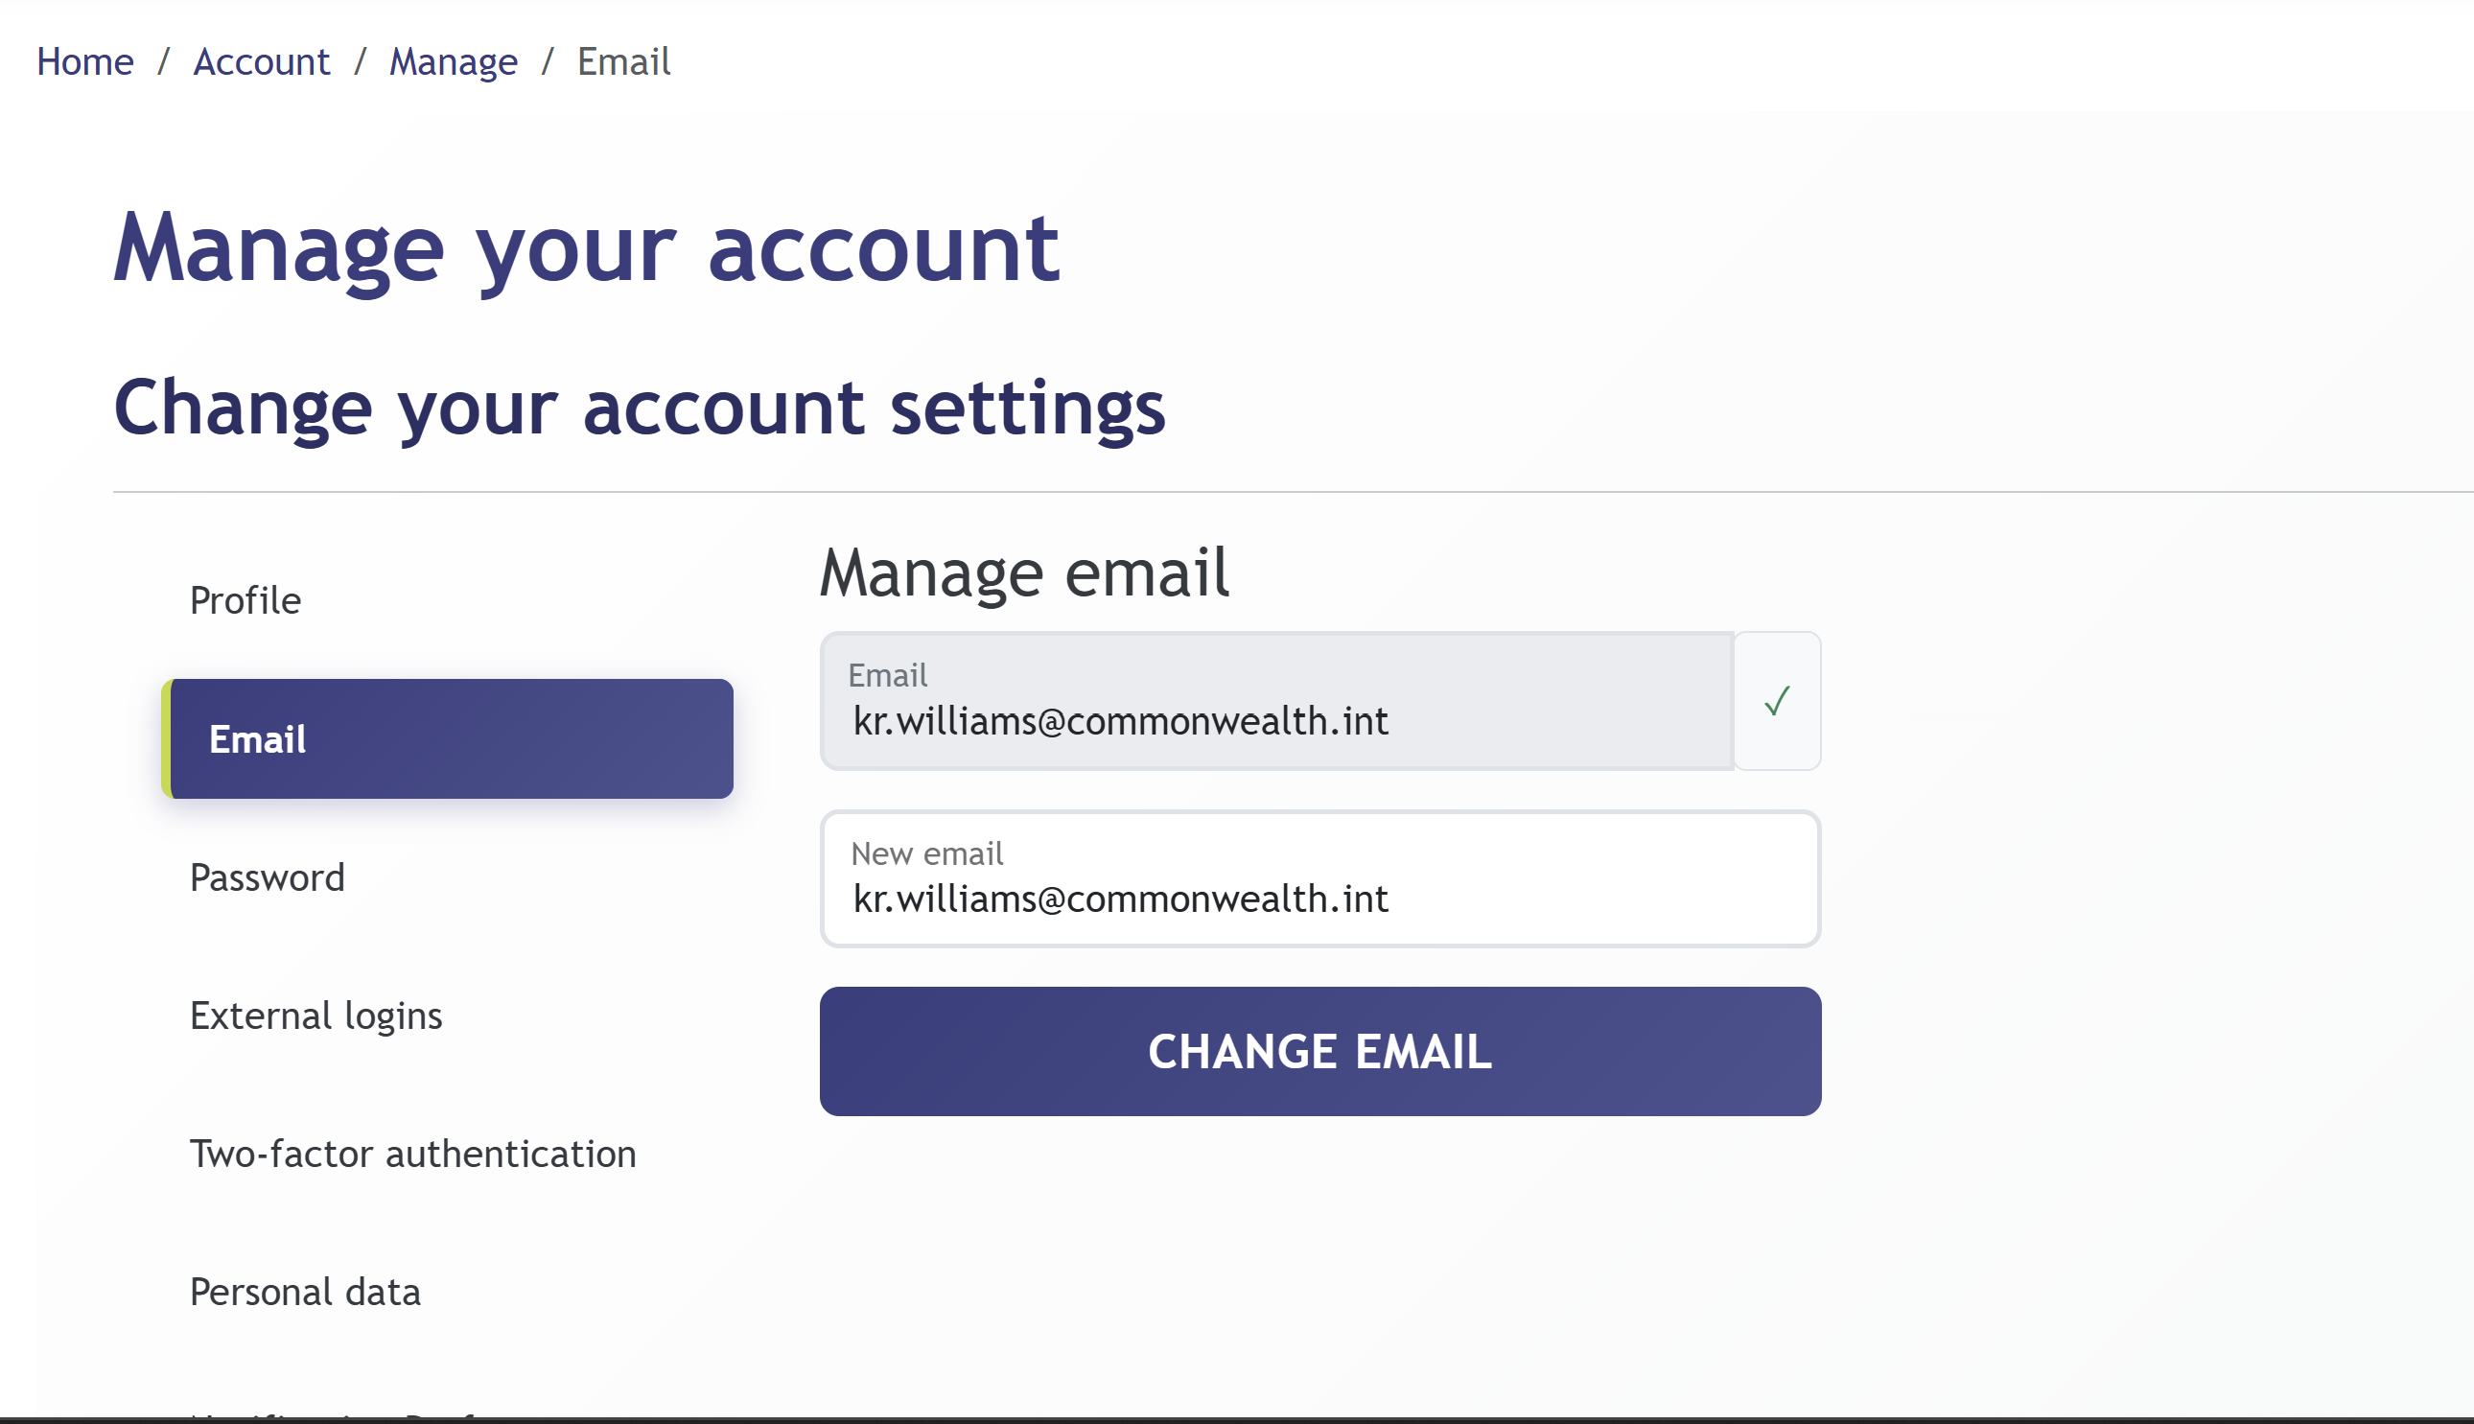
Change the email address associated with your account. Enter the new address and click CHANGE EMAIL. A verification email is sent before the change takes effect.
Note: Commonwealth SSO users’ email addresses are managed via the Commonwealth Microsoft 365 directory and cannot be changed here.

9.3 Password
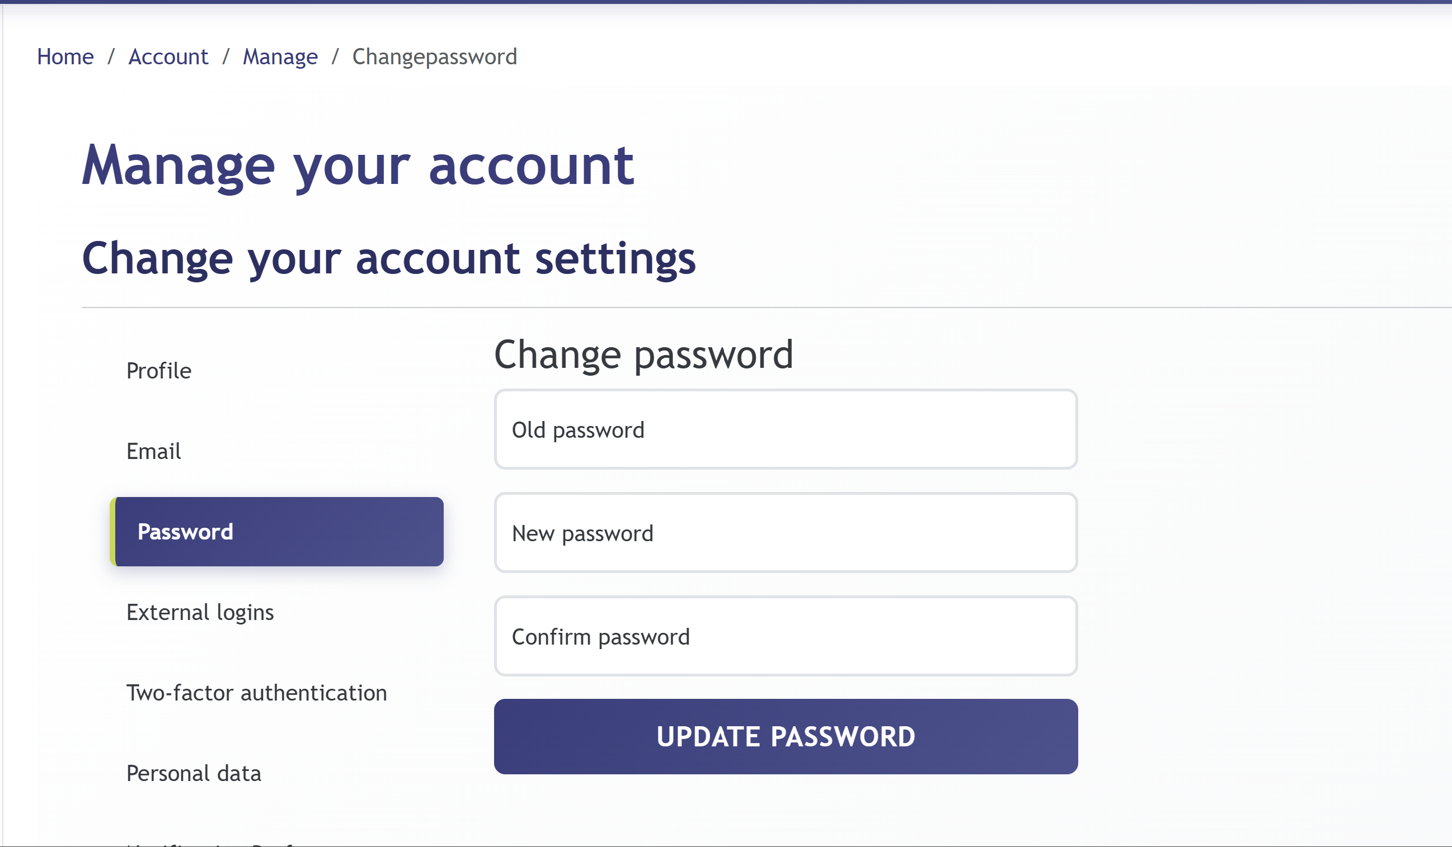
Enter your current password followed by your new password, then click UPDATE PASSWORD.
Note: This applies to local account users only. Commonwealth SSO users do not have a local password.

9.4 External Logins
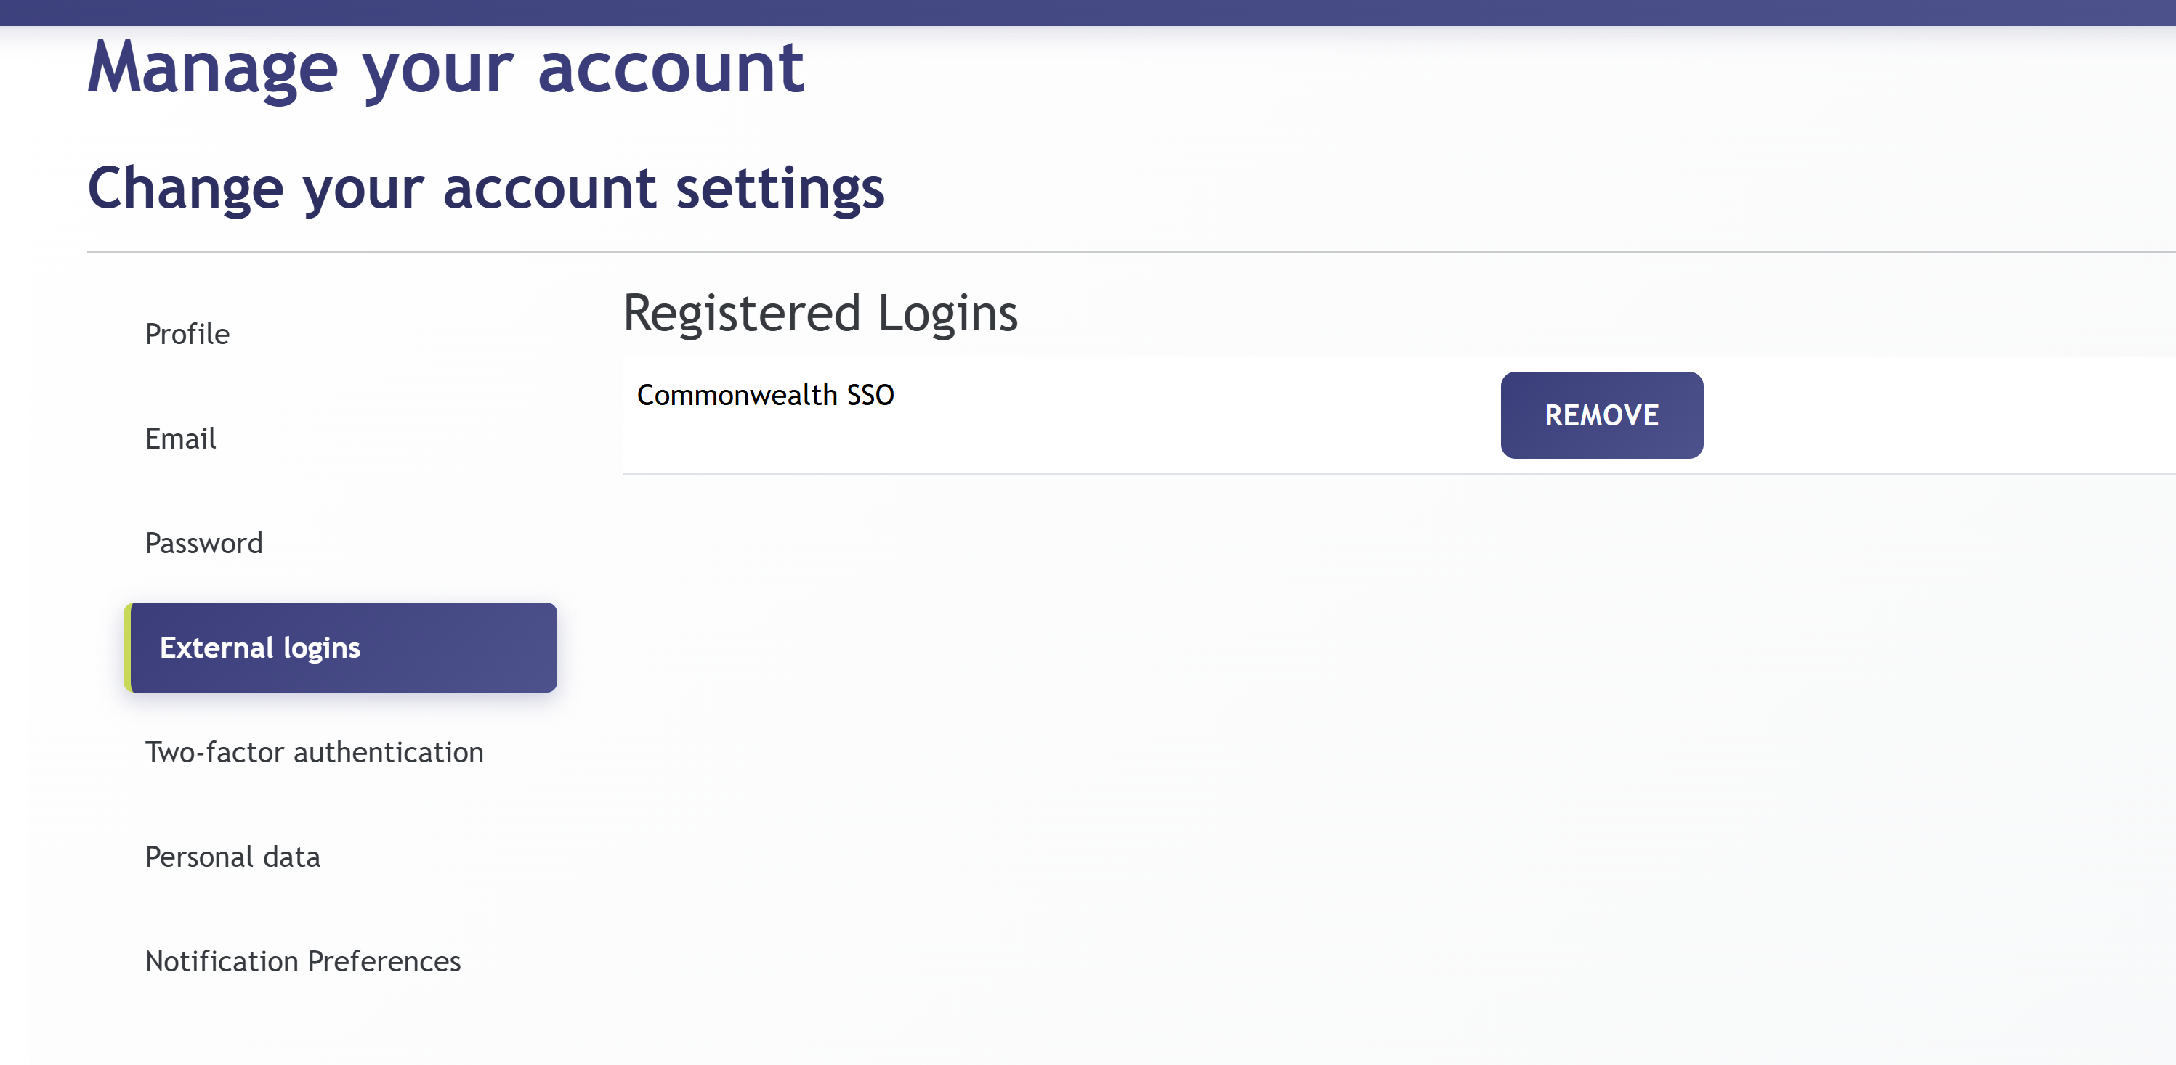
Shows which SSO providers are linked to your account. Commonwealth staff will see Commonwealth SSO here. The REMOVE button unlinks the provider, but only if a local password is set as an alternative.

9.5 Two-Factor Authentication (2FA)
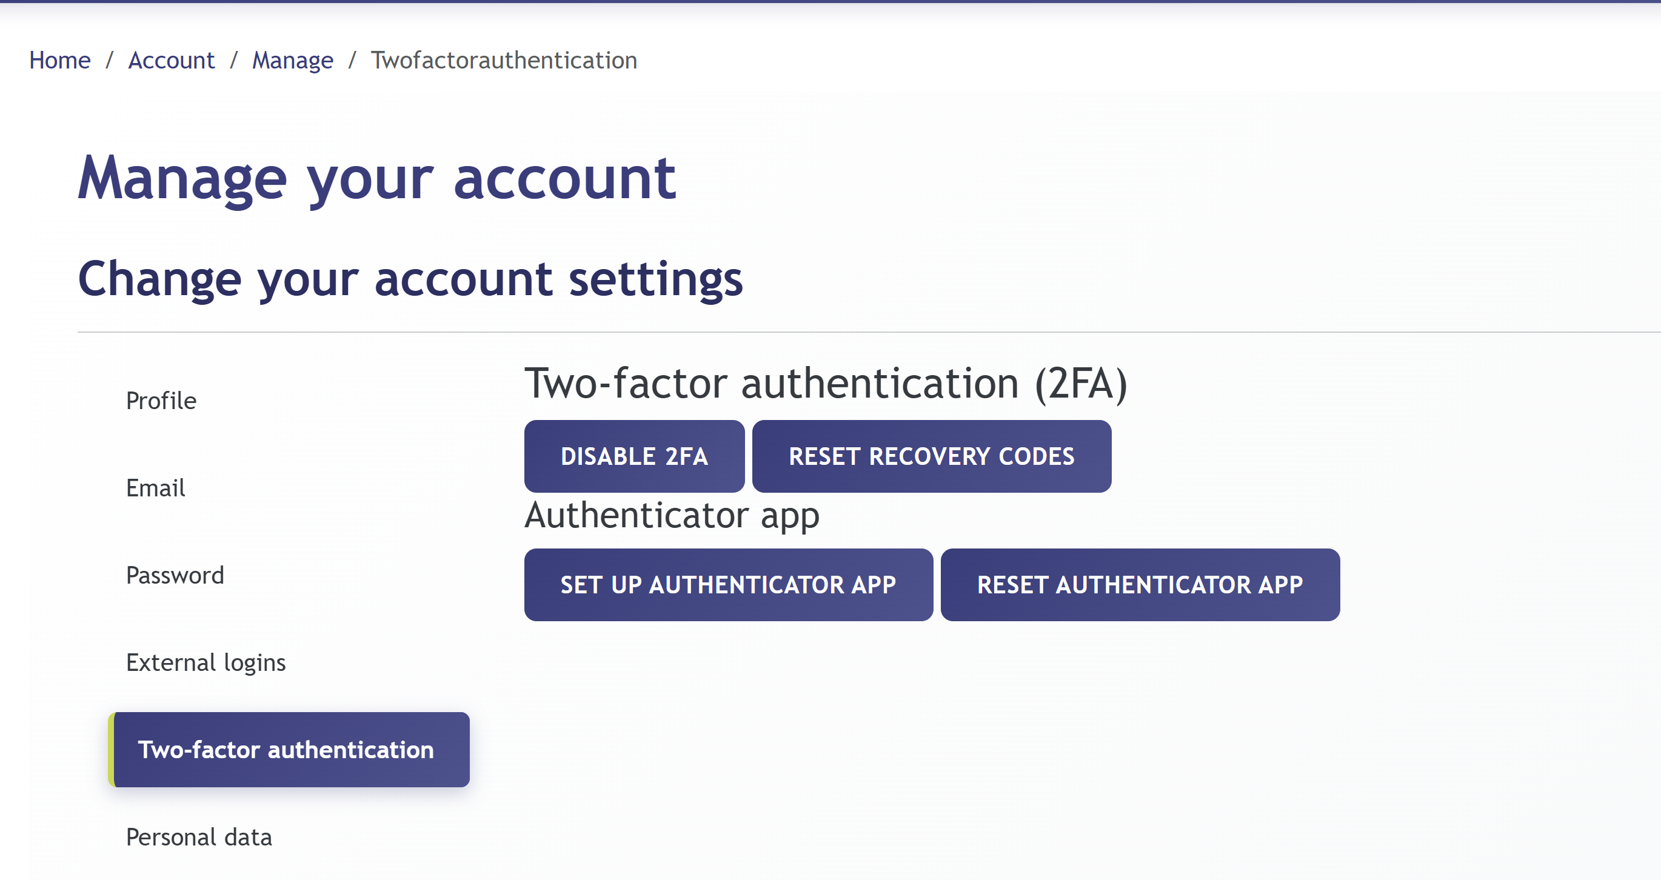
Adds an extra verification step when signing in with a local account:
- SET UP AUTHENTICATOR APP — links to an authenticator app (e.g., Microsoft Authenticator). Scan the QR code with your app.
- RESET AUTHENTICATOR APP — generates a new QR code if you change devices.
- DISABLE 2FA — removes two-factor authentication from your account.
- RESET RECOVERY CODES — generates new one-time backup codes in case you lose your authenticator device.
Note: 2FA is recommended for all local account users. Commonwealth SSO users are covered by the Commonwealth’s existing MFA policy.

9.6 Notification Preferences
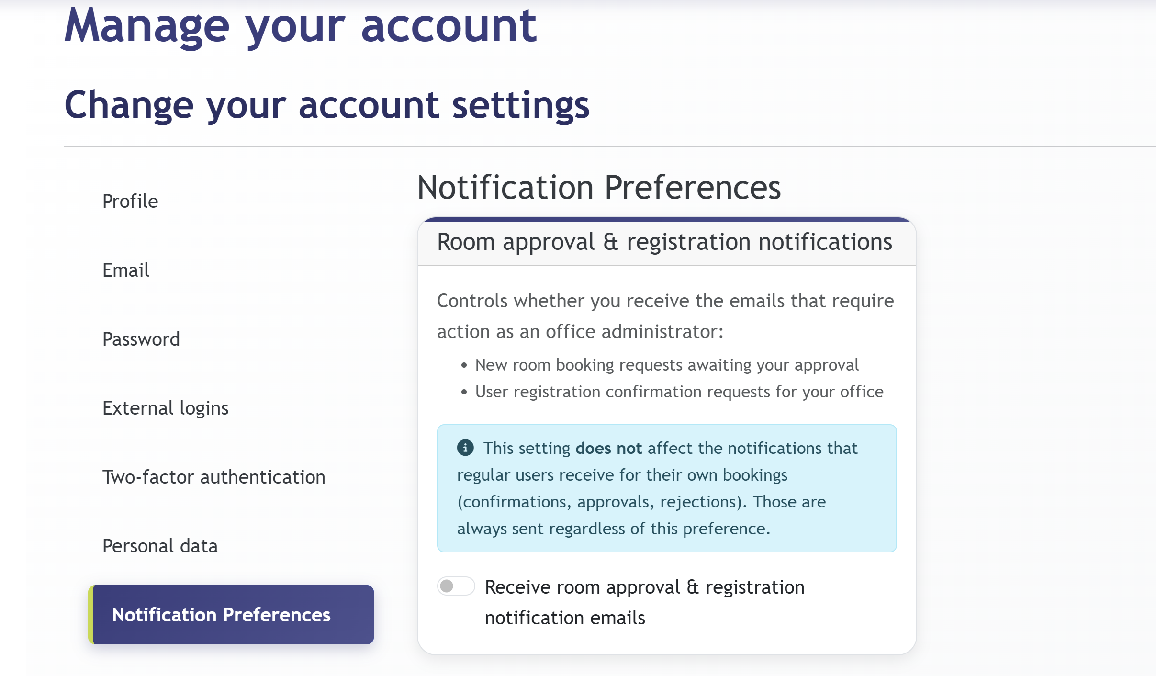
This section is visible to Office Administrators and Administrators only. It controls whether you receive the administrative emails that require your action:
- New room booking requests awaiting your approval.
- User registration confirmation requests for your office.
Note: This setting does NOT affect regular users’ own booking notifications. Booking confirmations, approvals, and rejections are always sent to the organiser and main contact regardless of this preference.
The toggle is enabled by default when the Office Administrator role is assigned but can be switched off at any time.

10. Tips and Best Practices
- View the room calendar before submitting a request to confirm your preferred slot is free. This avoids conflicts and speeds up approval. – Check availability first
- Submit requests as far in advance as possible. Rooms in high demand — especially fine rooms and large conference facilities — fill up quickly. – Book early
- When you are flexible on which room to use, this tool identifies suitable free rooms instantly without having to check each calendar individually. – Use Find Available Rooms
- Ensure the Number of Participants reflects the actual expected headcount. The approving administrator may reassign a more appropriately sized room. – Be accurate with participant numbers
- If an administrator requests further information, upload supporting documents (agenda, programme, delegate list) via Booking Details while the booking is still in Requested status. – Upload documents promptly
- All booking status changes generate email notifications. Check your inbox — and spam folder — after submission to track the approval process. – Watch your email
- If you have a @commonwealth.int or member government work email, always use the COMMONWEALTH SSO button. This keeps your login in sync with your office credentials and avoids duplicate accounts. – Commonwealth staff: always use SSO

